**Introduction**

We’re illustrating a story about the evolution of technology. It is like the evolution of biology but with one crucial difference. The evolution of biology is seamless. In nature, all animals and plants are all born slightly different. The animals that compete best get more food and procreate more children. This process is called natural selection. In nature, no animal or plant can suppress another. Whichever lifeform is more resourceful with time and energy wins the game of evolution.

As humanity creates technology, we’re, in a sense evolving new lifeforms. But we have new technological adaptations like warmer coats instead of having biological adaptions like thicker fur. Human evolution is tied to the technology we invent. But we don’t have free natural selection. Some people suppress innovation and resist people getting their hands on new and better technology. This suppression is either by force, or by creating fake stories like racism or sexism to supposedly justify why some races, classes, or genders shouldn’t be allowed to own better technology like books, telescopes, etc.

There are more details of course, but that is the summary of what I’m writing about. I’m using the lessons of evolutionary biology to re-interpret human politics and economics as a process of stunted and resisted technological evolution.

This story has a bunch of characters described below.

**Characters and Props**

The story of technological evolution has six characters.

* **The Reader.** The person we want the reader/viewer to see themselves as. No prominent features or clothing. Can be a person from any era. This character observes and travels with the story. So far, the Reader has been usually a male. Please feel free to draw a female too. But the look should say the same.

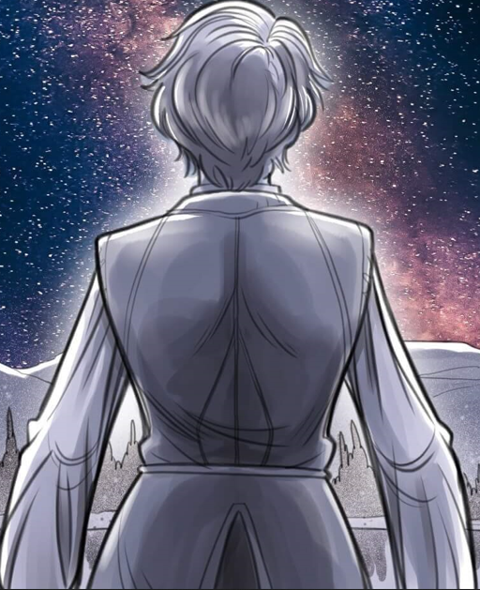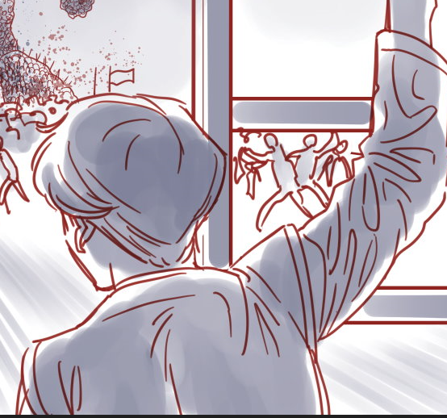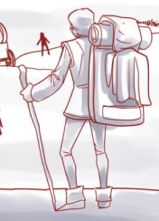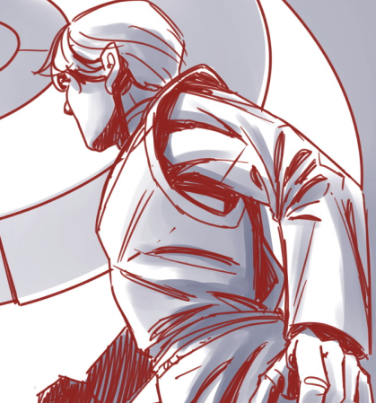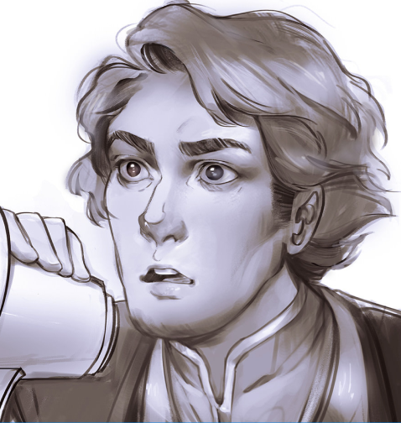 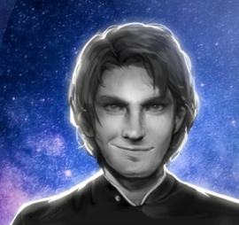

* **The Hero.** The person who innovates and creates new technology. Galileo, Ada Lovelace, Linus Torvalds are historical examples. Often depicted as heroes from popular movies. Luke Skywalker, Hermione, Morpheus.

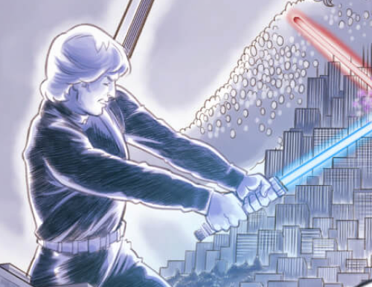

* **The Antagonist**. The person who controls a powerful technology and will lose out if new technology is allowed to spread to more people. They actively resist new technology with force, or by telling stories why some people shouldn’t be allowed to use new technology. Often depicted as a villain from stories, Darth Vader, Agent Smith, Voldemort.

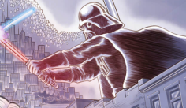

* **The Sidekick**. This person isn’t an innovator but fights with the Hero. This person is minimally dressed and often depicted as “faceless” because they recognize the technology they hold and fight for defines them more than their personality, races, or gender.

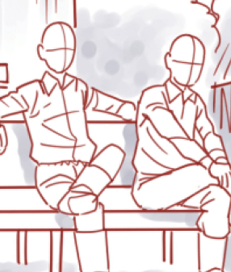

* **The Extra**. This person doesn’t want to get involved in the hero’s fight. They follow the rules and believe the stories of the antagonist and are content using old technology. They’re very emotional and are often depicted with patches on their clothes and wearing a Greek stage mask. A broken mask symbolizes an Extra becoming a Sidekick.

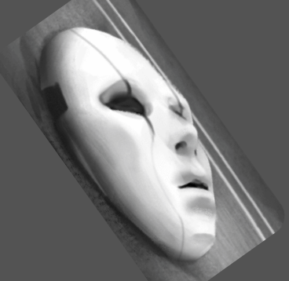 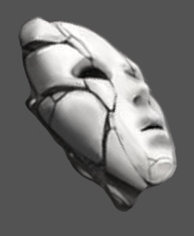

* **The Leviathan**. This character symbolizes society. It is made up of many individuals who come together to make a single body. The head is often a king but can also be the Hero or Antagonist. Sometimes illustrated as a “Wizard of Oz” ghost because the Leviathan doesn’t exist and is only a shared belief that connects lots of people. Sometimes will be depicted fighting another Leviathan to signify a war between one society and another, or civil a war between the society.

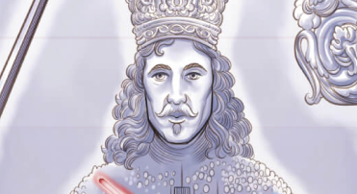 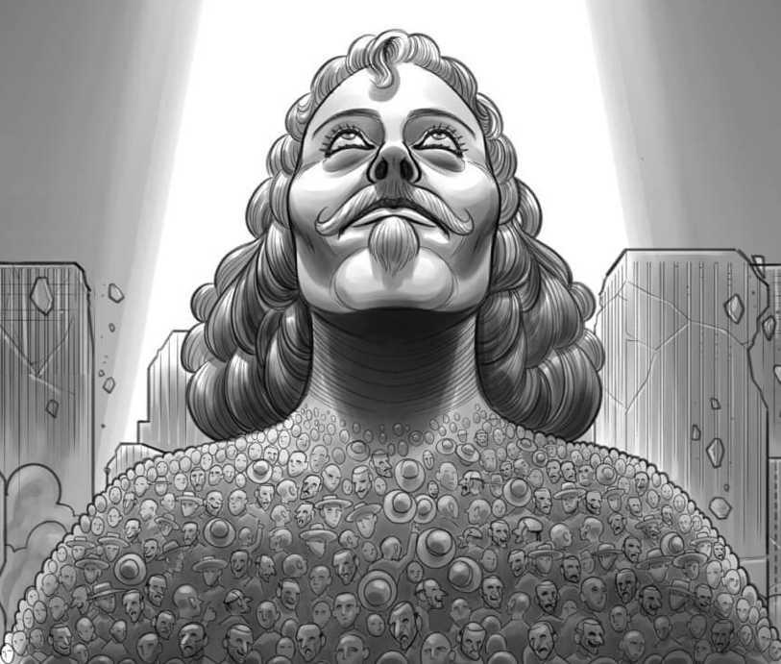 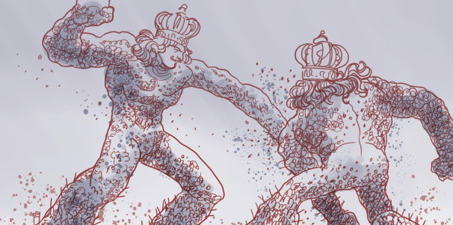

* **Levers of Power**: New technology is what Heros and Antagonists are fighting over. Innovators want to invent new tools and get people to use it. Like Elon Musk and electric vehicles. Antagonsits control old technology like gas cars and don’t want to loose their power inside society, which they will if new technology is allowed to flourish. Since there are many new technologies in history, we can symobolize them as a “Lever of Power” or showing the technology itself. New technology is often a bit brilliantly colorful to symbolize life and evolution.

 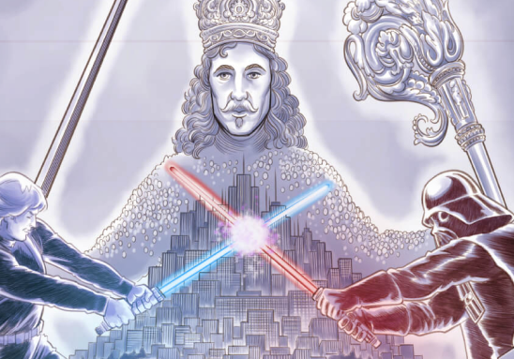 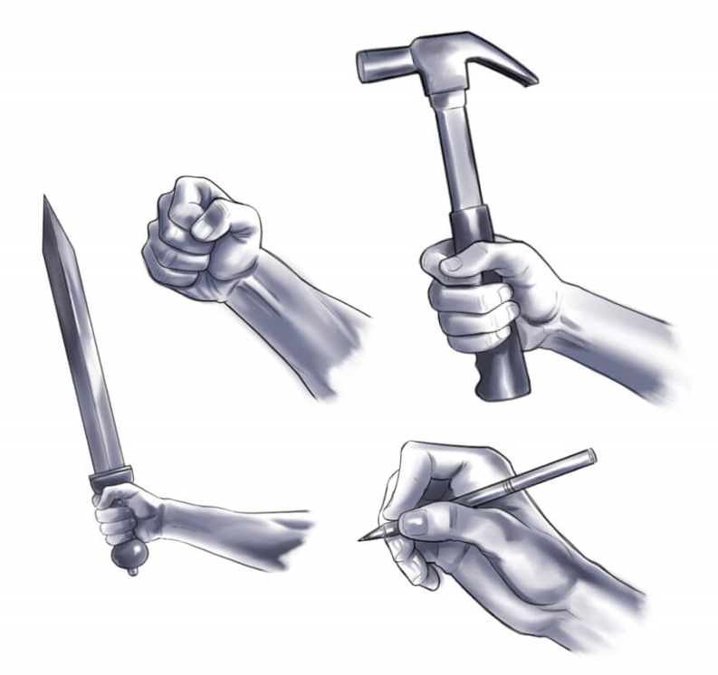 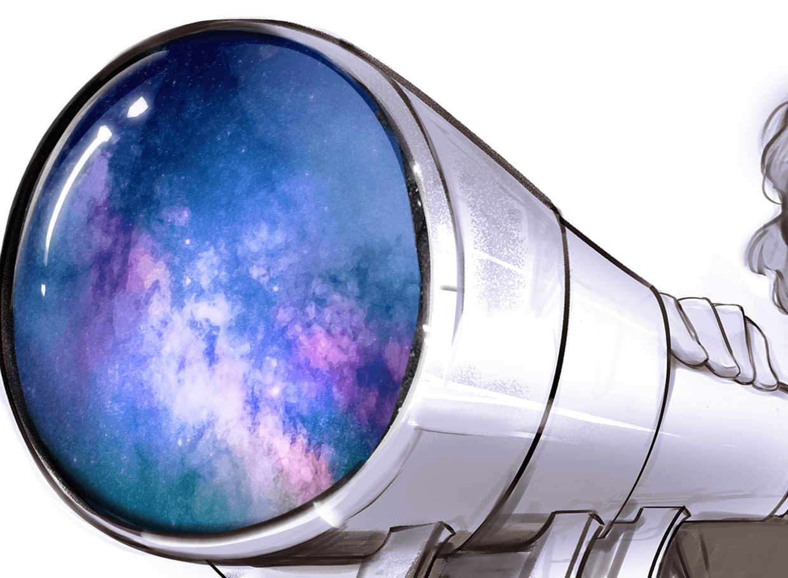



* **Old Technology:** Antagonistscontrol old technology. As technology ages, it gets less powerful and helpful to regular people. To keep people interested, Antagonists must keep use advertisements and glitz. I’m not sure what’s the best way to showcase old technology because every technology was at one point a “Lever of Power”. Excessive jewelry is an option. Perhaps shade a tool in dying/decaying color? If you have any ideas, please try them out.

**Illustrations**

**Self-Reflection:**

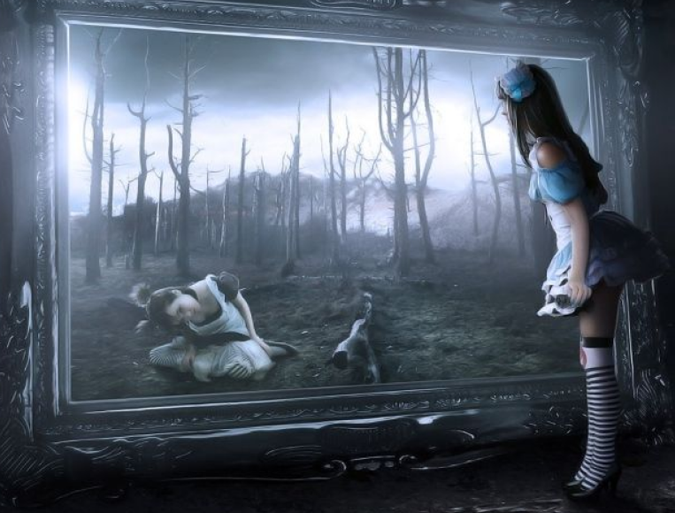

One important theme in our story is self-reflection. The ability of a person to see themselves for who they are in the story of evolution.

The person in front of this mirror has the attire of an Extra, they wear clothing with lots of patches on it. Their patches/clothing signifies their loyalty to social movements and causes. This person is very emotional, someone whose been to a lot of protests and gets emotional about politics. But they're suddenly questioning themselves and looking into the mirror. Their attire is Extra, but their facial expression is the curiosity of the Reader character.

The person looking back is a Sidekick, with neater clothing, has no patches.

**Yin and Yang. Good and Evil. Evolution vs Stagnation.**

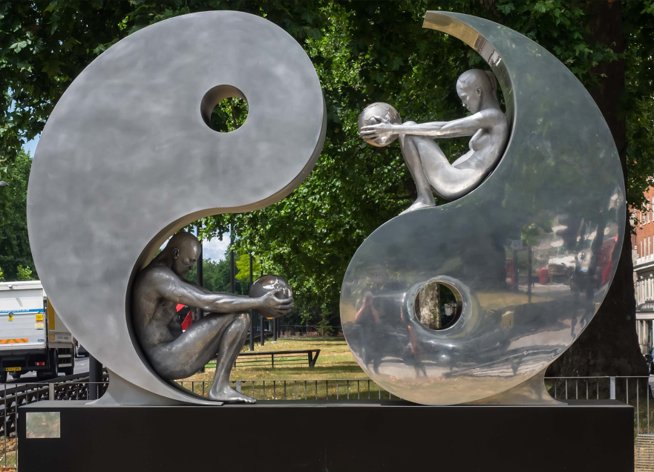 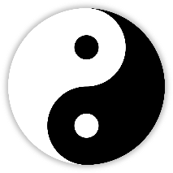

Yin and yang describe opposite but interconnected forces.

This illustration is about the opposition of Evolution and. Stagnation. Hero and Antagonist. Sidekick and Extra. However, each side has elements of the other inside themselves.

Please use the statue as a starting point. There are multiple versions:

* + Hero (left/bottom) and Villain.
  + Sidekick (left/bottom) and Extra.
  + We’ll be returning to this illustration later to do a Evolution vs. Stagnation version

The Offer. Red Pill or Blue Pill.

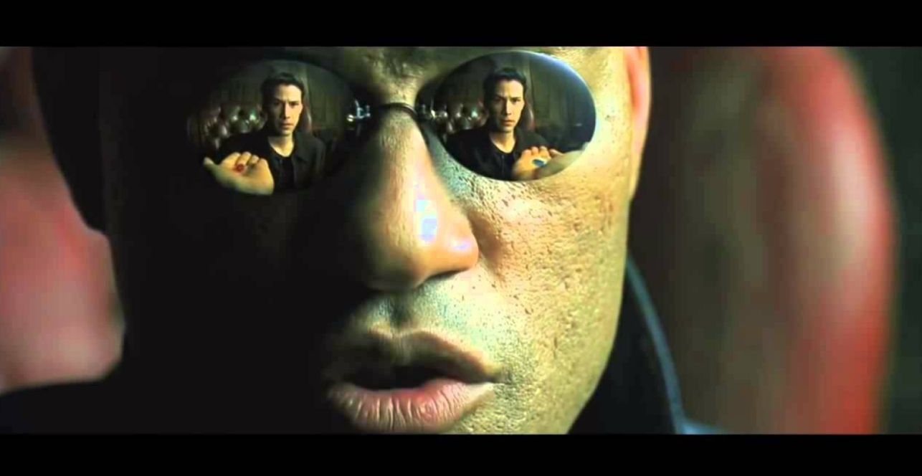

Heroes and Antagonists are natural enemies who constantly battle each other. But they also battle for supporters. Both want the population to become either Sidekicks or Extras.

This is a scene from the movie “The Matrix” where the Hero Morpheus is offering an Extra a choice. The red pill will teach him what the matrix is and turn him into a Sidekick (and later Hero). And the blue pill will return him to the comfortable life of an Extra. The matrix is the stories and lies Antagonists tell to keep people away from new tools.

How we incorporate technological evolution is changing out the pills for technology. If an Extra holds and learns new technology, they have automatically decided to support the Innovator/Hero. Please change the reflections as:

* + Red pill reflection: The Reader character reaching for a tool and becoming a Sidekick.
  + Blue pill reflection: The Reader character rejecting the tool and becoming an Extra.

Here’s the scene for reference.

<https://youtu.be/zE7PKRjrid4>

**The Teacher**

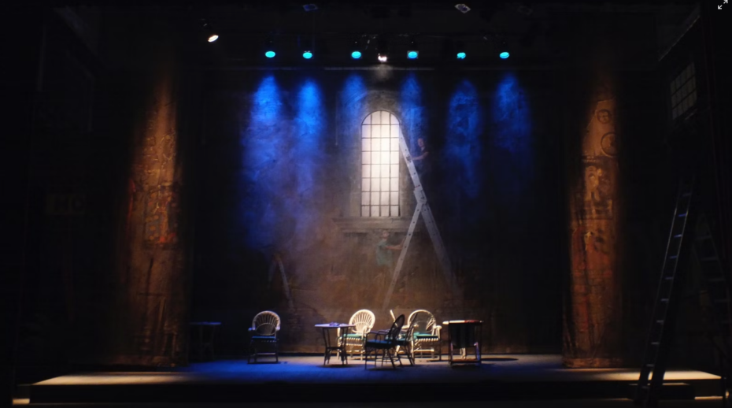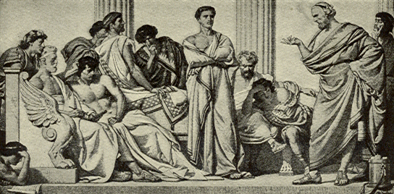

After the Sidekick joins the Hero to fight for evolution, he wants to understand his new reality. If the stories of the Antagonists are a matrix of lies, what is the truth?

This scene is about a Hero, teaching several Sidekicks philosophy. The scene is like Socrates teaching his eager students the nature of justice and truth.

Several students hold a technology, and there are ladders in the back and foreground to signify evolution (we’ll talk more into why ladders signify evolution later). This lesson has happened for thousands of years and will continue for many more. You can make the clothing and characters a mix of any era.

**Educated**

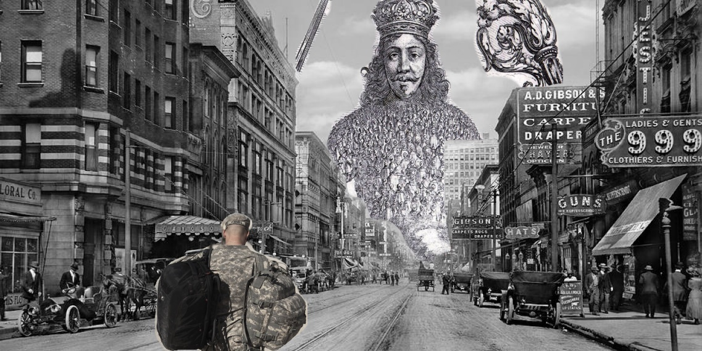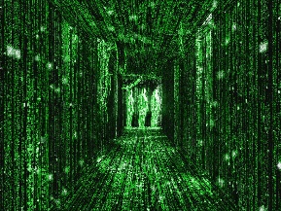

After committing to new technology, and learning about the philosophy of the Hero, this Sidekick now must live back in society.

He sees the world differently. Some people are wearing Extra’s Greek masks. A few people are faceless Sidekicks. There are even some Antagonists and heroes. Some advertisements have a trace of The Matrix green binary. And the Leviathan is above the city (I’m not sure what face the Leviathan should have, so for now we can use king.)